PROGRAMMING_SET 2_QUESTIONS :

1) Check IP address:

The IP address must be in the form of string like A.B.C.D

The length of A, B, C, or D can't be greater than 3.

The value of A, B, C, and D should lie between 0 to 255. Following are the valid combinations of each number of an IP address.

Any one- or two-digit number.

Any 3-digit number beginning with 1.

Any 3-digit number beginning with 2 if the second digit is 0 through 4.

Any 3-digit number beginning with 25 if the third digit is 0 through 5.

Leading 0's is not allowed.

Example

Input: str = "172.16.254.1"

Output: True

Input: str = "000.123.12.23.28"

Output: False

Input: str = "I.Am.not.an.ip"

Output: False

2) Java program to find Armstrong number

Example:

input : 153

output : true

input : 111

output : false

Explanation:

1^3 + 5^3 + 3^3 =153

3) Program to count number of duplicate words in given string

input String :"Welcome to Java Session Session Session"

output :2

4) Java Program to reverse each word in String

input :hello world

output :olleh dlrow

5) Java Program to rotate(right) an array

input array:[1,2,3,4,5,6,7]

rotate:2

output :[3,4,5,6,7,1,2]

input array:[90,45,67,54,32,78]

rotate:1

output :[45,67,54,32,78,90]

6) Given a sentence of string, in that remove the palindrome words and print the remaining.

Input:

He did a good deed

Output:

He good

Input:

Hari speaks malayalam

Output:

Hari speaks

7) Given two strings, the task is to find if a string can be obtained by rotating another string can be obtained by rotating another string by two places.

Examples:

Input:

String1 = "amazon" String2="azonam" rotateCount=2

Output:

Yes

Explanation :

Rotating string1 by 2 places in anti-clockwise given the string2

Input:

String1 = "amazon" String2="zonama"

Output:

Yes

Explanation :

Rotating string1 by 3 places in clockwise given the string2

8) How to find all the leaders in an integer array in Java?

Write a Java program to find all the leaders in an integer array. An element is said to be a leader if all the elements on it’s right side are smaller than it. Rightmost element is always a leader. For example, if {14, 9, 11, 7, 8, 5, 3} is the given array then {14, 11, 8, 5, 3} are the leaders in this array.

Output :

The leaders in [12, 9, 7, 14, 8, 6, 3] are :

3 6 8 14

The leaders in [8, 23, 19, 21, 15, 6, 11] are :

11 15 21 23

The leaders in [55, 67, 71, 57, 51, 63, 38] are :

38 63 71

The leaders in [21, 58, 44, 14, 51, 36, 23] are :

23 36 51 58

9) Harshad Number (Niven Number) Program :

Harshad number or niven number is a number which is divisible by the sum of its digits. For example, 21 is a Harshad number because 21 is divisible by the sum of its digits (2+1=3). An interviewer ask this type of logical programs in interview to test how do you implement logic in your code.

What Is Harshad Number Or Niven Number?

Harshad number or Niven number is a number which is divisible by the sum of its digits.

For example,

21 is a Harshad number because it is divisible by the sum of its digits.

21 –> sum of digits –> 2+1 = 3 and 21 is divisible by 3 –> 21/3 = 7.

111 is a Harshad number because it is divisible by the sum of its digits.

111 –> sum of digits –> 1+1+1 = 3 and 111 is divisible by 3 –> 111/3 = 37

153 is a Harshad number. It is divisible by the sum of its digits.

153 –> sum of its digits –> 1+5+3 = 9 and 153 is divisible by 9 –> 153/9 = 17

10) Reverse and add until you get a palindrome :

Write a Java program to take input number from the user, reverse it and add it to itself. If the sum is not a palindrome then repeat the procedure until you get a palindrome.

Example :

If 7325 is input number, then

7325 (Input Number) + 5237 (Reverse Of Input Number) = 12562

12562 + 26521 = 39083

39083 + 38093 = 77176

77176 + 67177 = 144353

144353 + 353441 = 497794 (Palindrome)

Input :

Enter Number :7325

Output:

7325 + 5237 = 12562

12562 + 26521 = 39083

39083 + 38093 = 77176

77176 + 67177 = 144353

144353 + 353441 = 497794

11) Reverse the string with preserving the position of spaces :

Write a Java program to reverse a string with preserving the position of spaces. For example, if “I Am Not String” is the given string then the reverse of this string with preserving the position of spaces is “g ni rtS toNmAI”.

Output :

I Am Not String —> g ni rtS toNmAI

JAVA JSP ANDROID —> DIOR DNA PSJAVAJ

1 22 333 4444 55555 —> 5 55 554 4443 33221

12) Diamond Pattern :

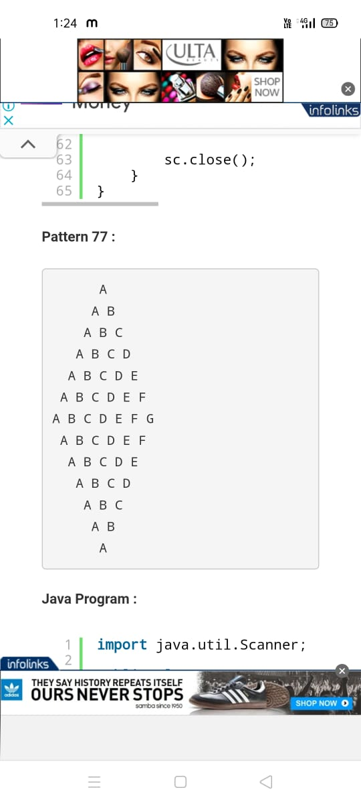

13) Disarium Number Program In Java

Write a Java program which checks whether given number is Disarium number or not. A number is said to be Disarium if it is equal to sum of its digits raised to the power of their respective position in the number.

135 is a Disarium number. Because, it is equal to sum of its digits raised to the power of their respective position.

135 = 11 + 32 + 53

135 = 1 + 9 + 125

135 = 135

14) Problem : Print All Substrings Of A String In Java

Write a Java program or function which prints all substrings of a given string. Your program should take input string from the user and print it’s all possible substrings. For example, if “Java” is the input string then its all possible substrings are,

J

Ja

Jav

Java

a

av

ava

v

va

a

15) Pronic number program in Java

Write a Java program to check whether the given number is pronic or not. Pronic number is a number which is the product of two consecutive integers i.e n(n+1).

Pronic Number Examples :

Below are some examples of Pronic number.

2 = 1 x 2

6 = 2 x 3

12 = 3 x 4

20 = 4 x 5

30 = 5 x 6

42 = 6 x 7

56 = 7 x 8

72 = 8 x 9

90 = 9 x 10

Output 1 :

Enter a number :

342

342 is a pronic number

18 x 19 = 342

Output 2 :

Enter a number :

1406

1406 is a pronic number

37 x 38 = 1406

Output 3 :

Enter a number :

979

979 is not a pronic number

16) How to find saddle point of a matrix in Java?

Saddle point of a matrix is an element in the matrix which is smallest in its row and largest in its column. For example,

6 3 1

9 7 8

2 4 5

In this matrix, 7 is the saddle point. Because it is the smallest in its row (2nd row) and largest in its column (2ndcolumn).

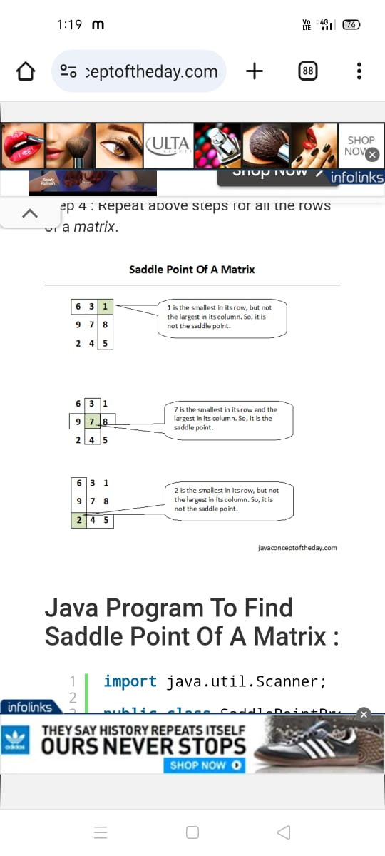

17) Selection Sort

18) Bubble sort

19) Insertion sort

20) Quick sort

21) Linear Search

22) Binary Search

23) Write a program in Java to print the elements of the matrix in Wave Order as shown below. (The matrix can have different numbers of rows and columns).

Input:

1 2 3

4 5 6

7 8 9

Output:

1 4 7

8 5 2

3 6 9

24) How to check whether one string is a rotation of another in Java?

Write a Java program to check whether one string is a rotation of another. For example, If “JavaJ2eeStrutsHibernate” is a string then some rotated versions of this string are “StrutsHibernateJavaJ2ee”, “J2eeStrutsHibernateJava“, “HibernateJavaJ2eeStruts“.

25) How to Convert Math number to equivalent readable word in java?

The format for writing numbers in words is like this

Unit,ten,hundred,thousand,million,billion,trillion,quadrillion,quintillion.

For example :

Input : 123456789

Output: One hundred twenty three million four hundred fifty six thousand seven hundred eighty nine

26) How to remove specific characters in the String?

To remove specific characters in the String .For example,

If the original string is "Alive is awesome" and the user inputs string to remove "alwsr" then it should print "ive i eome" as output .

If the original string is "Learning never stops" and the user inputs string to remove "estp" then the it should print "Larning nvr o" as output .